**Linux Assignment**

Q1. Create a directory "exercise" inside your home directory and create a nested (dir1/dir2/dir3) directory structure inside "exercise" with a single command.

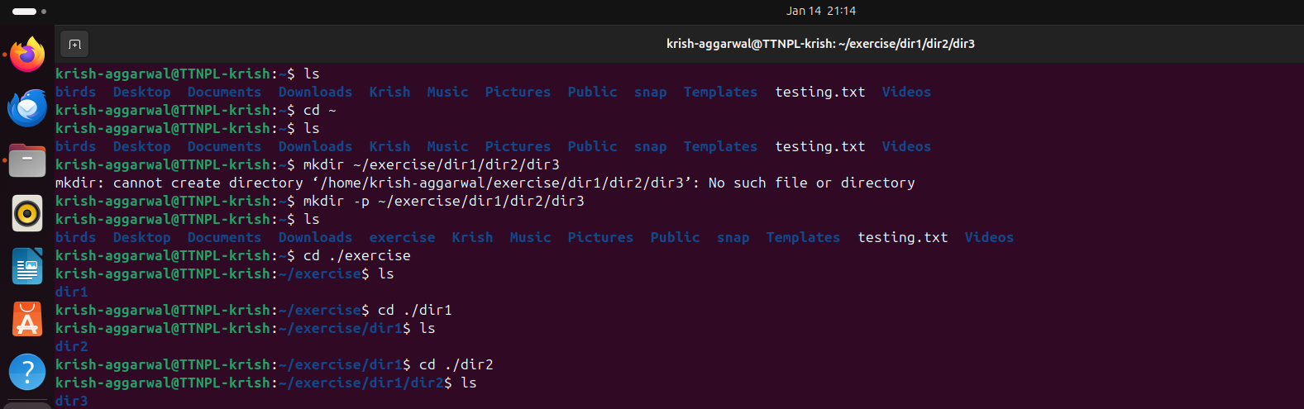

a. Create two empty files inside dir2 directory: emptyFile1, emptyFile2 in single command

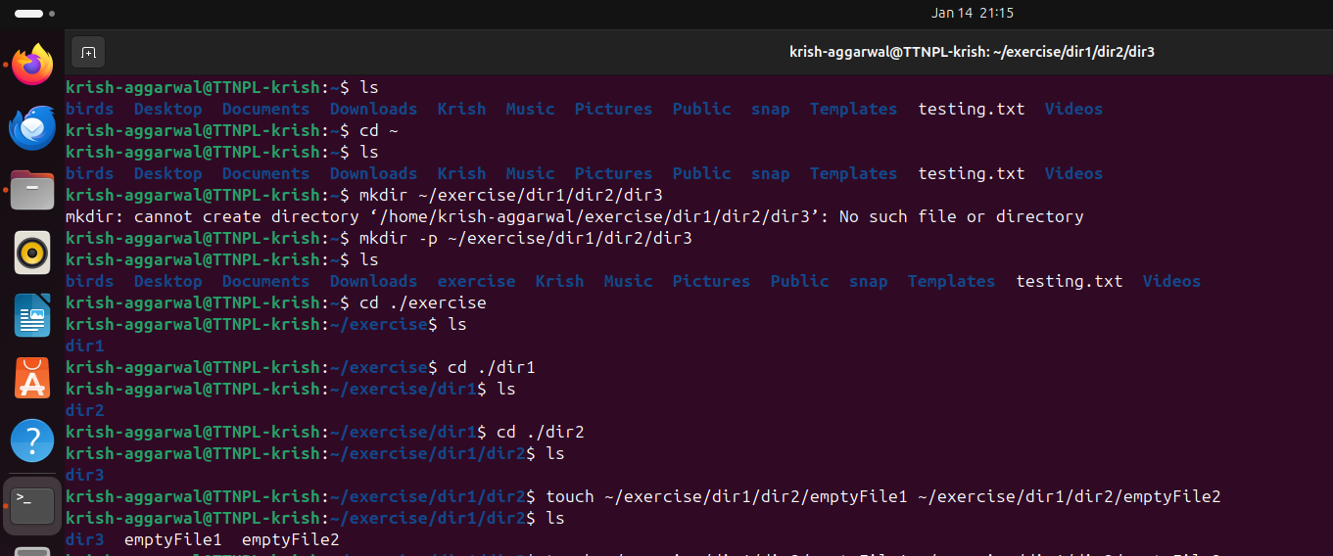

b. Change the timestamp of  empty File1, emptyFile2 which are exist in dir2.

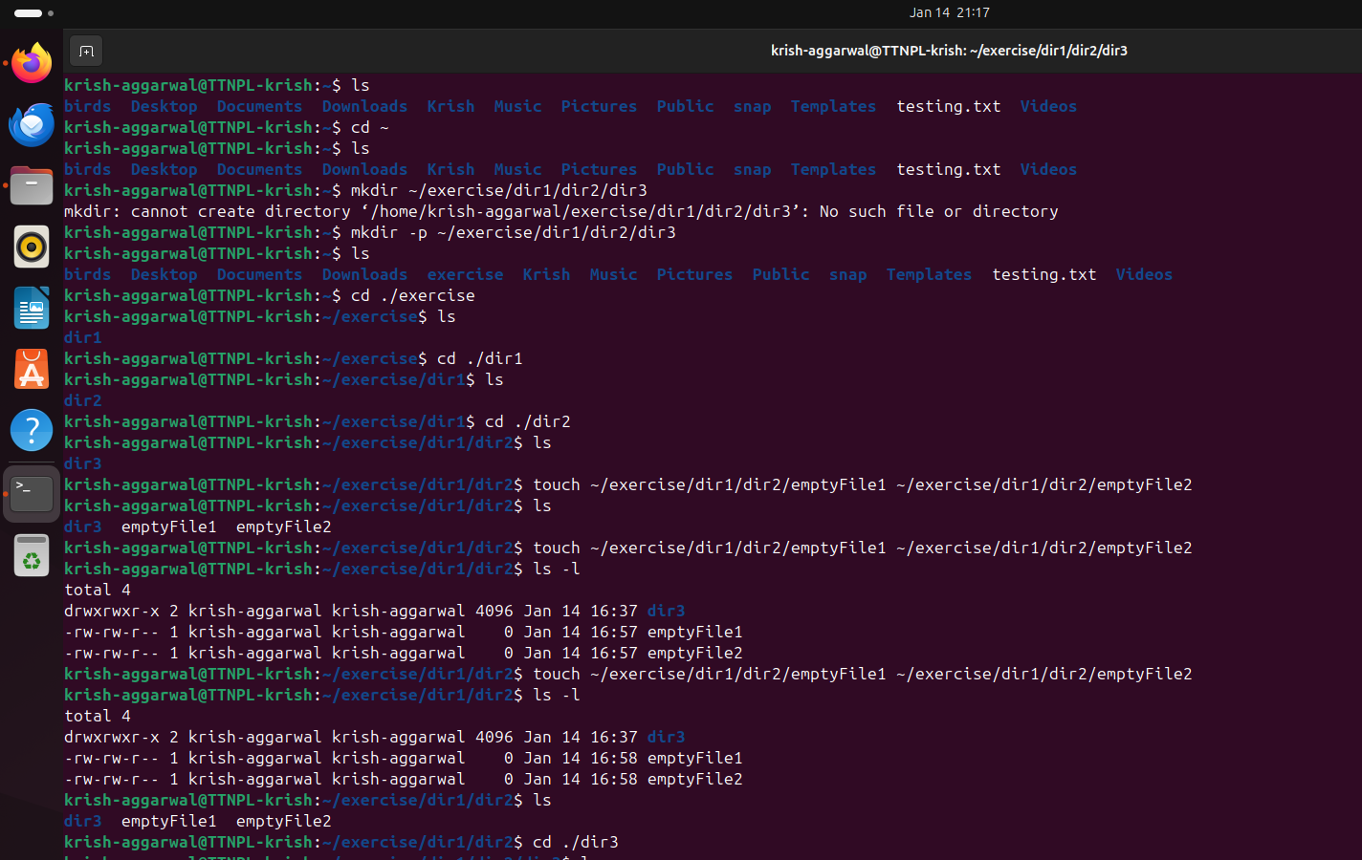

c. Create one file file1.txt containing text "hello world" and save it.

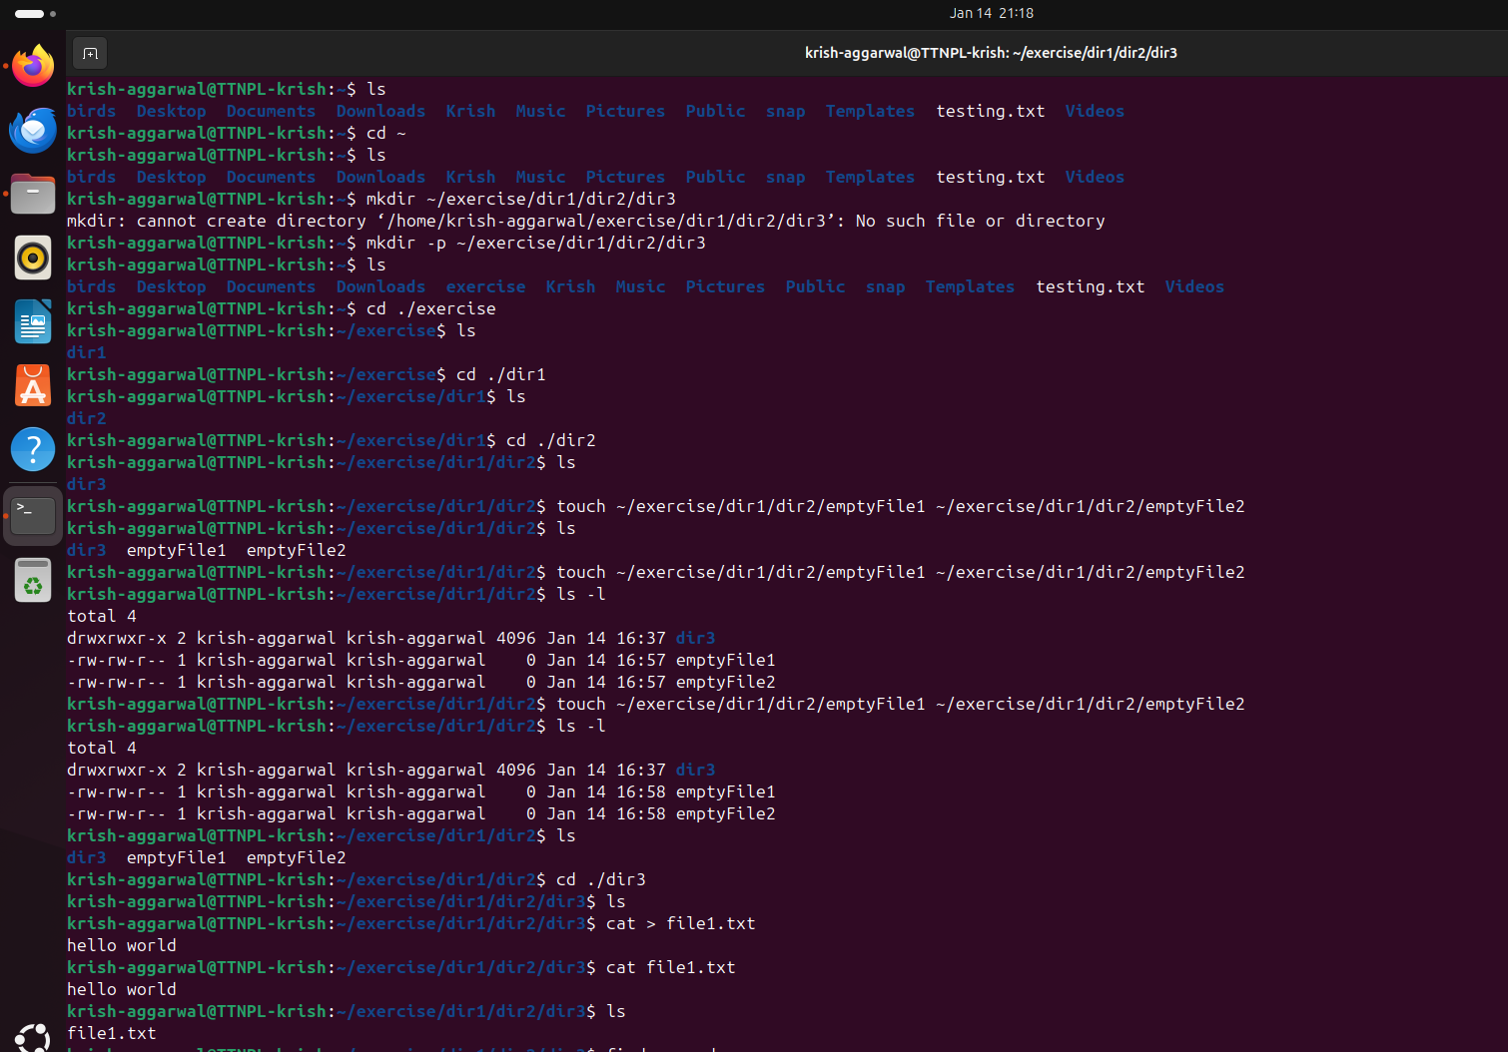

Q2. Find a "passwd" file using find command inside /etc. copy this files as passwd_copy and then rename this file as passwd_backup.

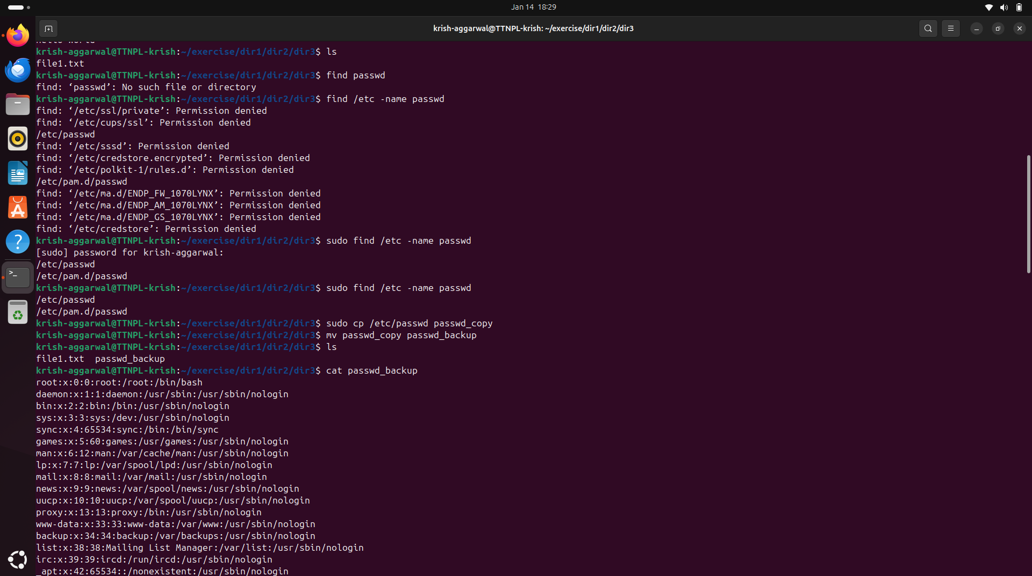

a. Try reading passwd_backup file in multiple tools: less,more,cat,strings etc and find the difference in their usage.

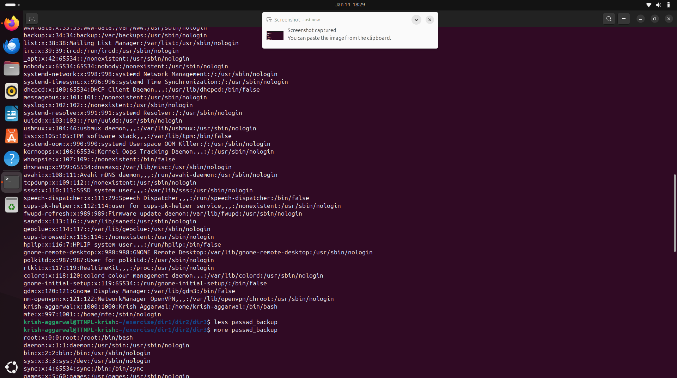

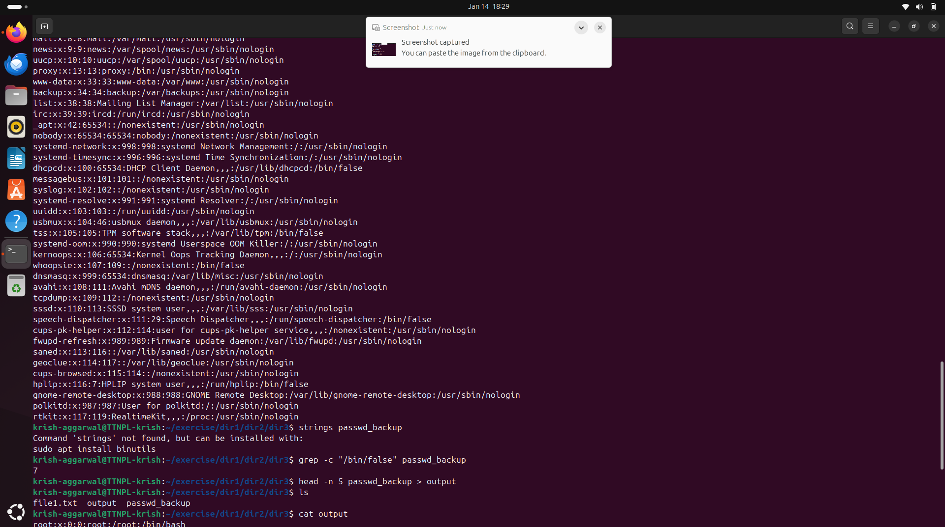

b. Find out the number of line in password_backup containing "/bin/false".

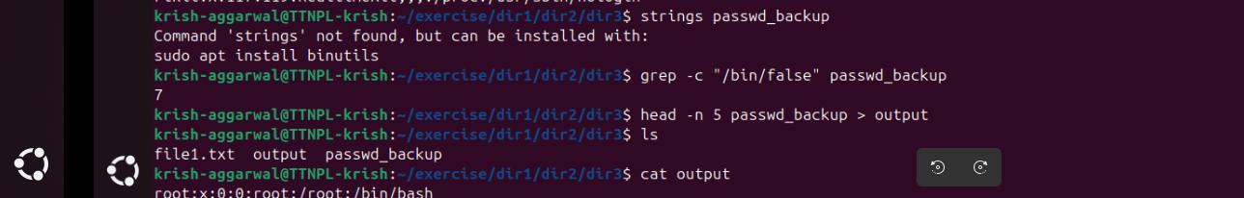

c. Get the first 5 lines of a file “password_backup” and  Redirect the output of the above commands into file "output". Also, get the lines 6-10 from the above file.

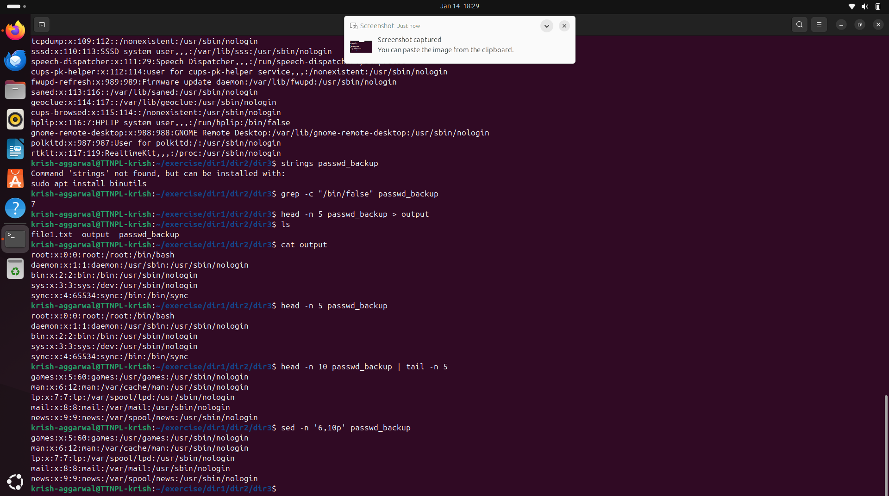

Q3. Create a "test" user,create its password and find out its uid and gid.

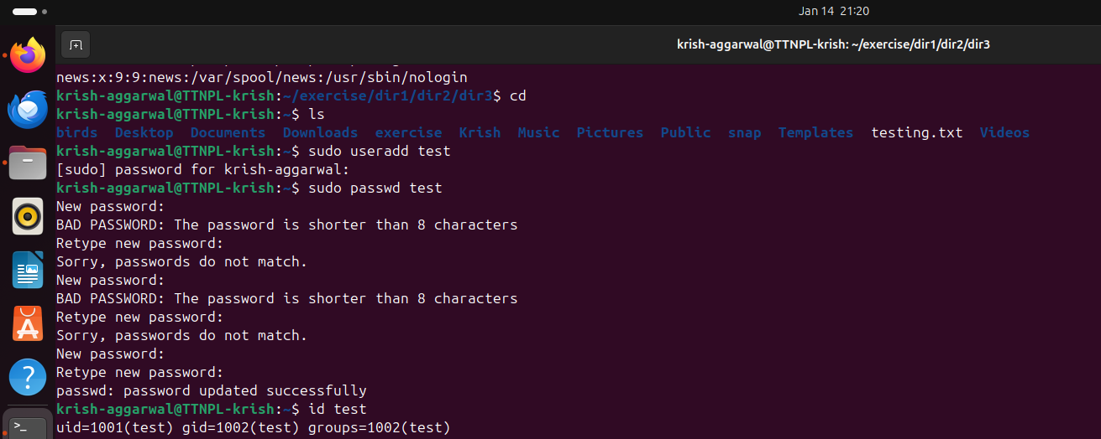

a. Login as test user and edit the "output" file created above. Since the permission won't allow you to save the changes. Configure such that test user can edit it.

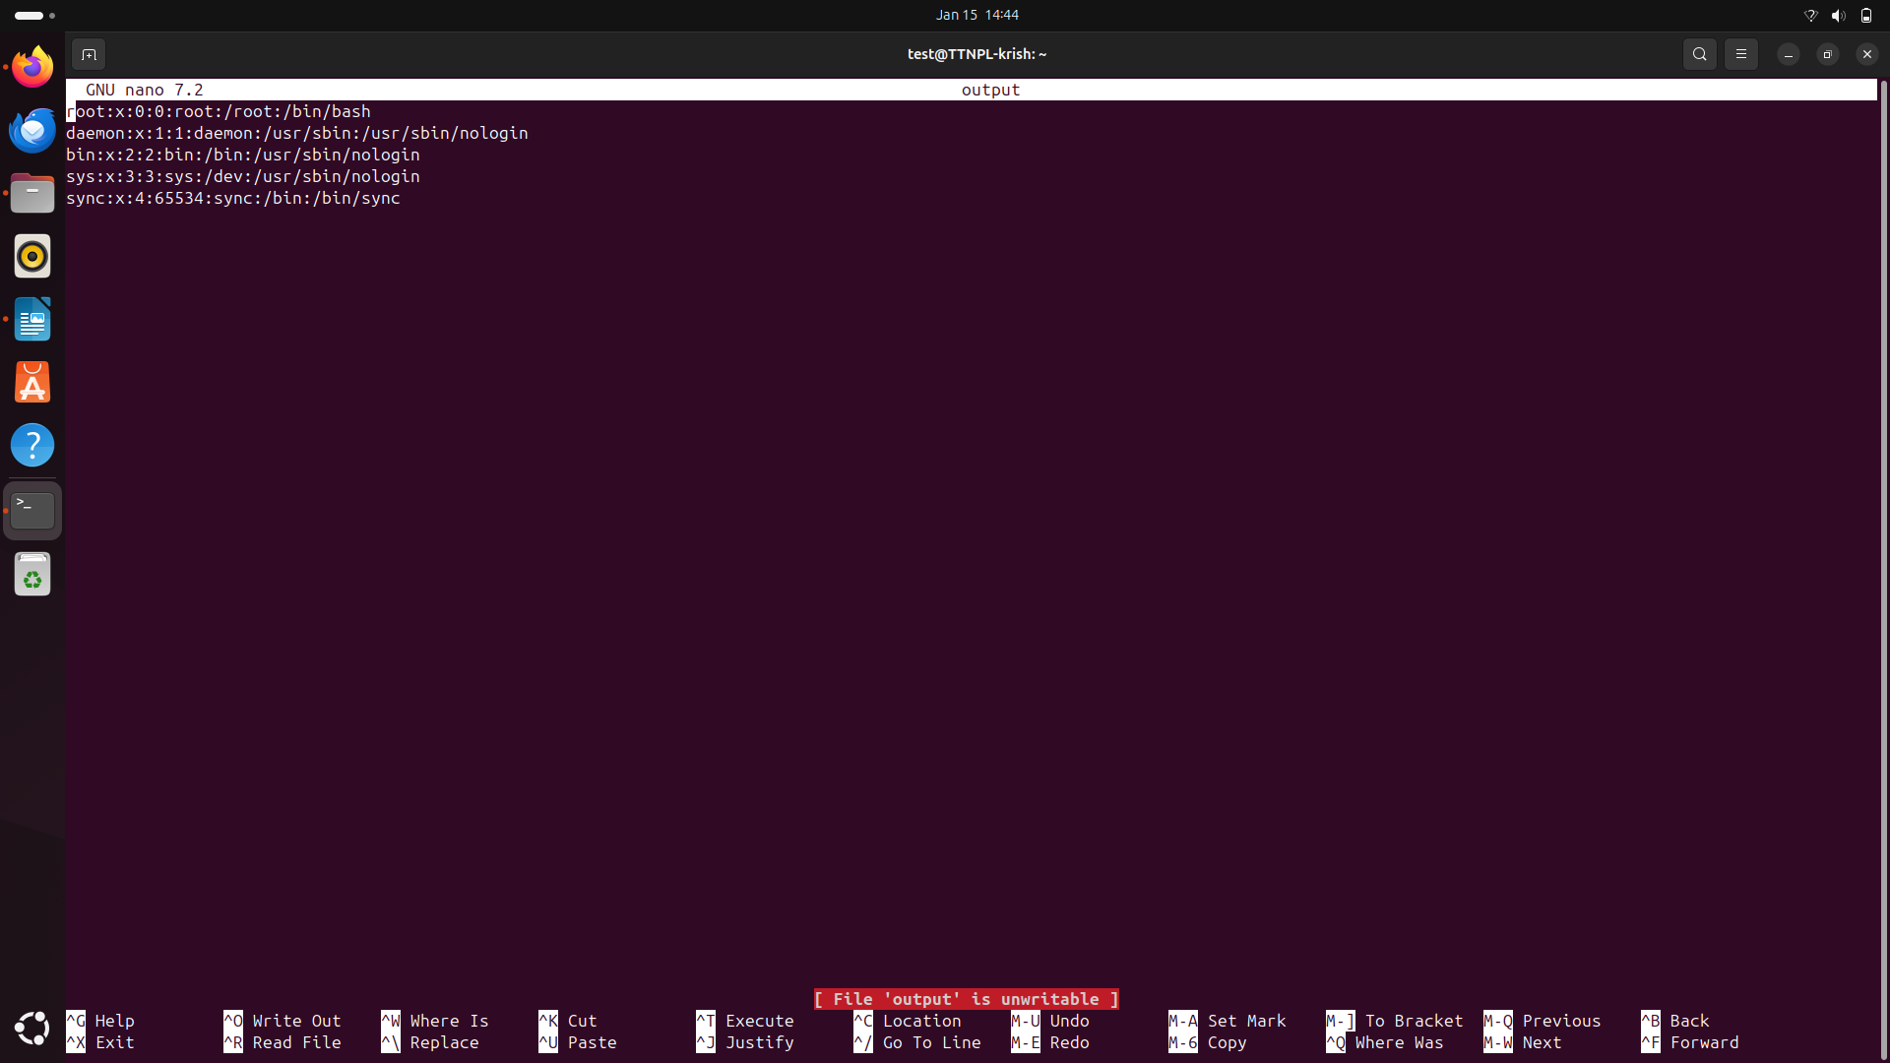

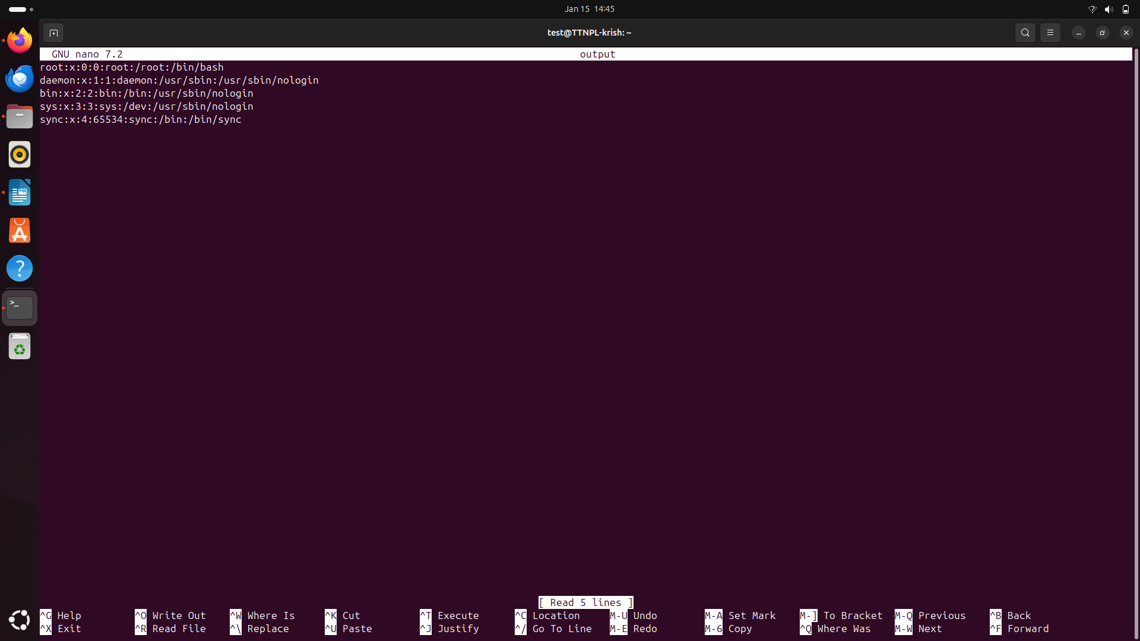

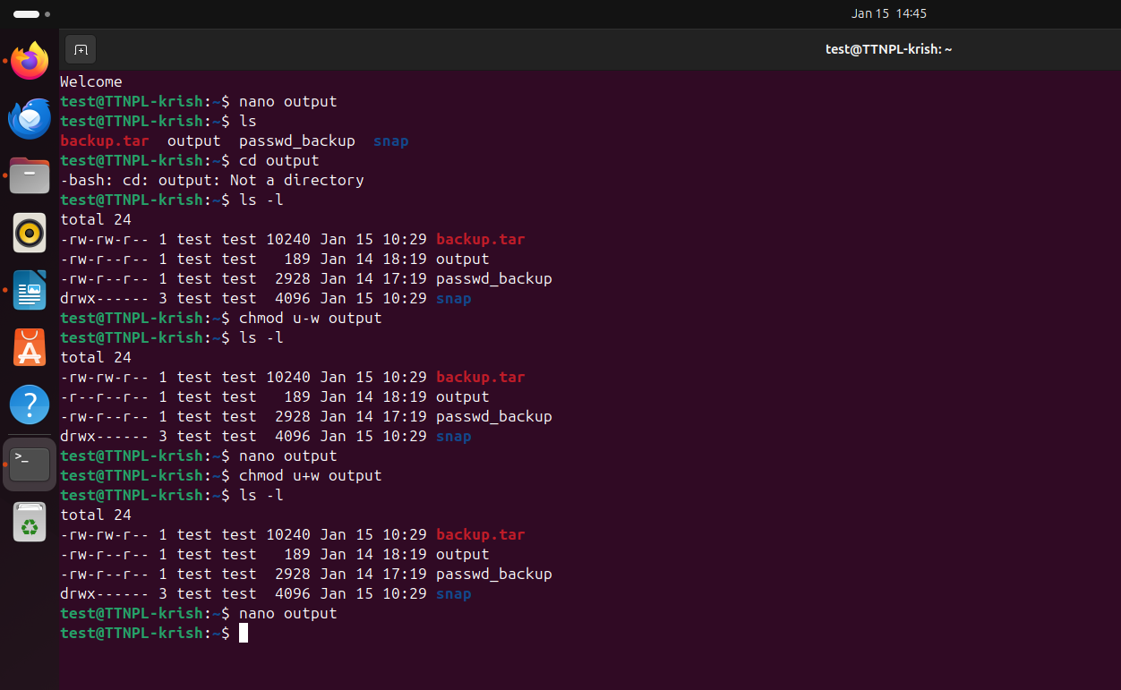

b. Add group owner of the "output" file as the secondary group of test user and check/change the "output" file permission if it is editable by group. Once done revert the changes

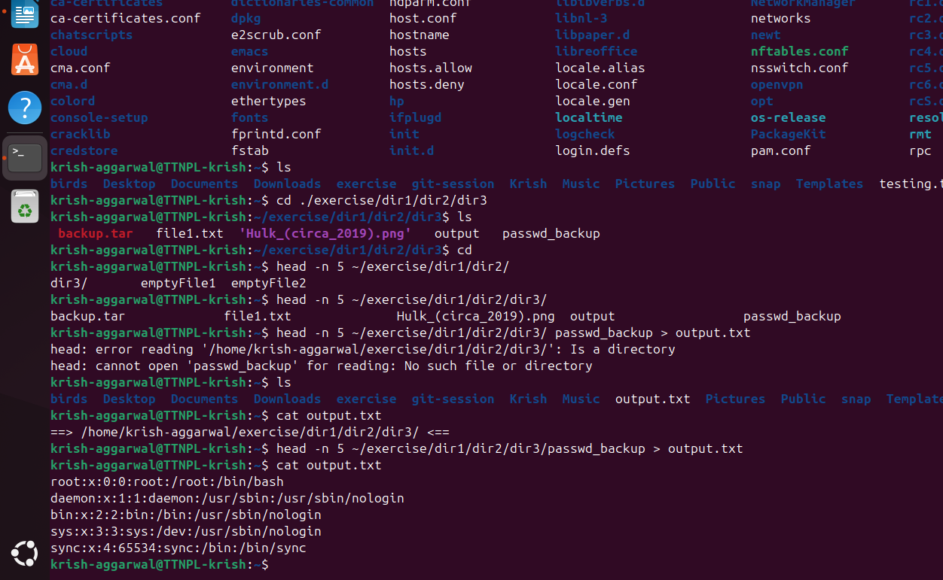

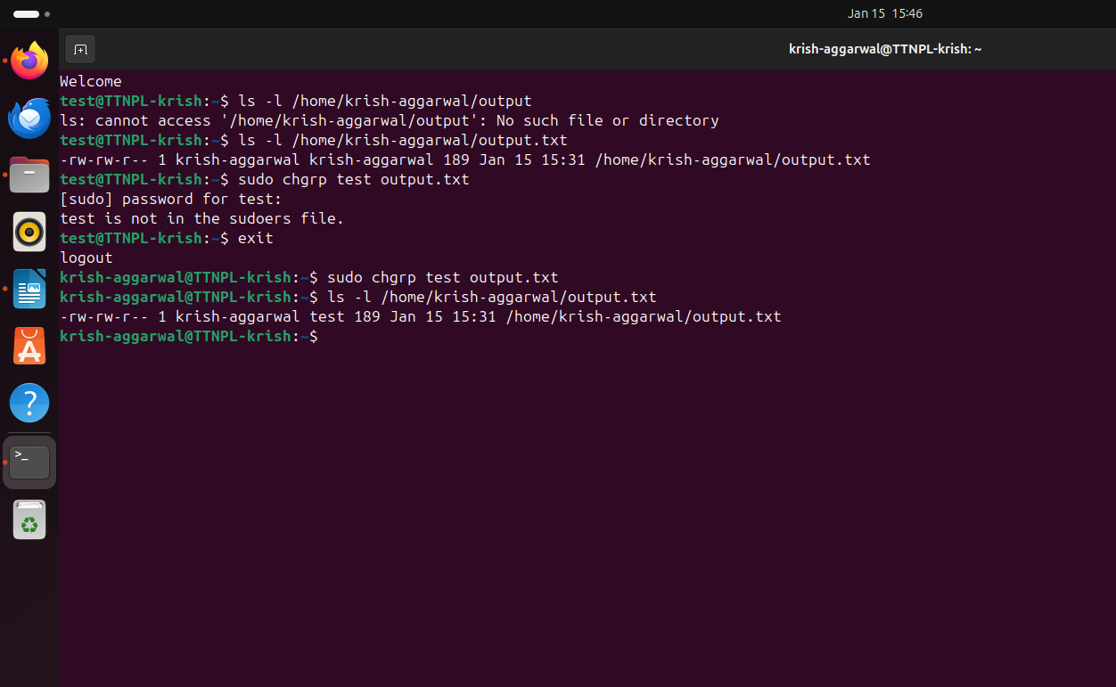

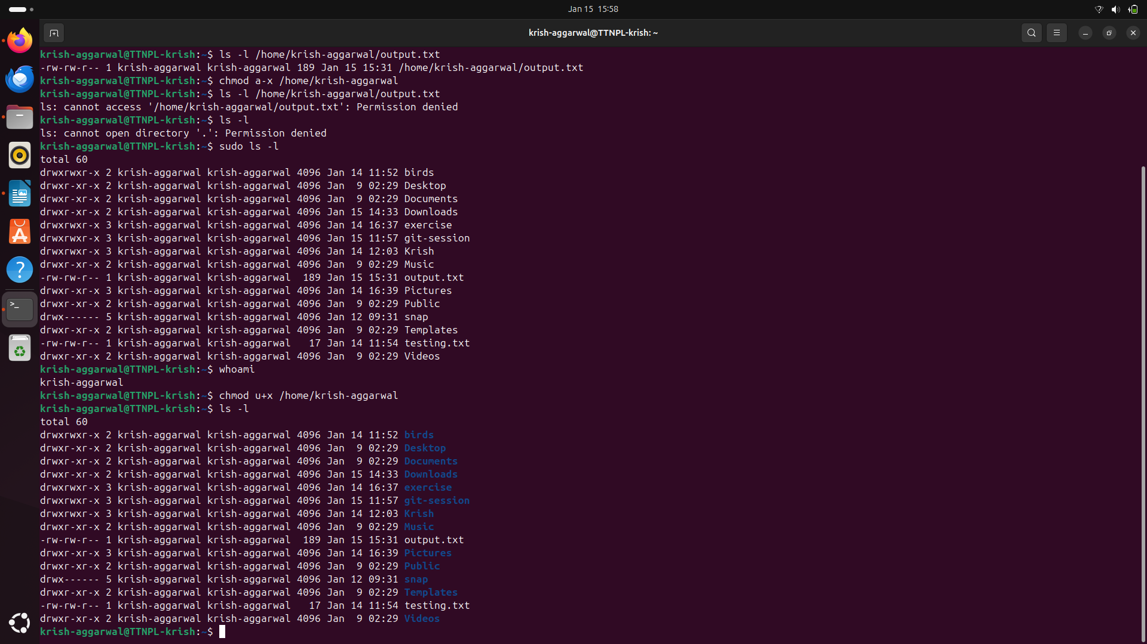

c. Make the file editable to the world so that test user can access it. Revert the changes after verification

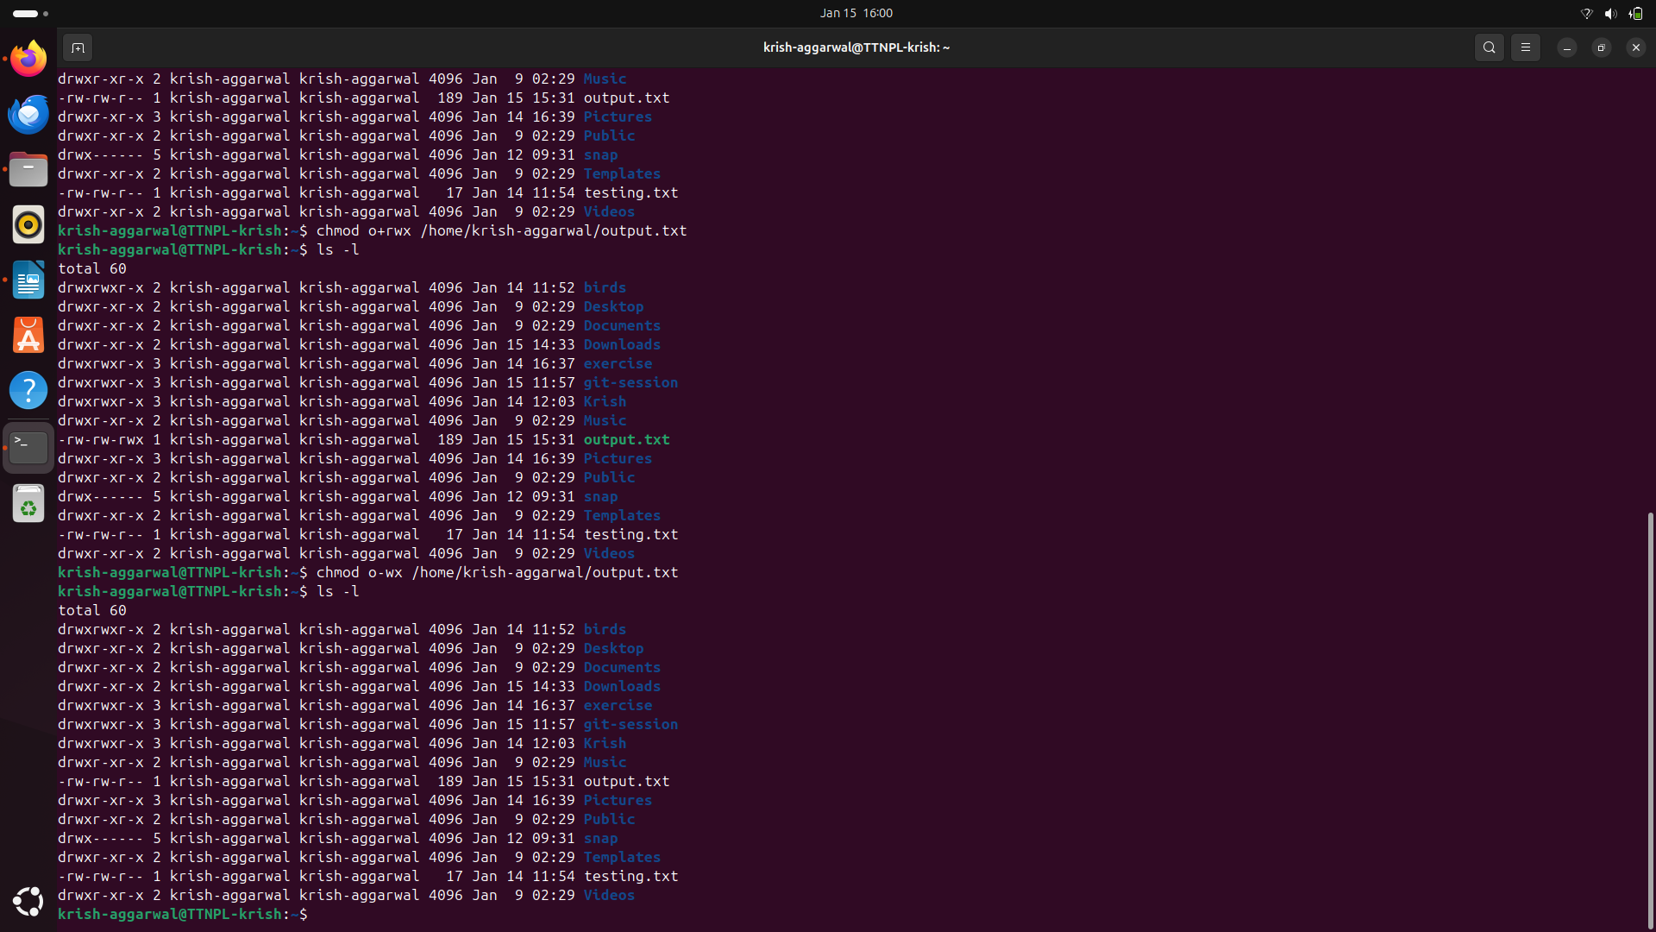

d. Change the ownership to edit the file.

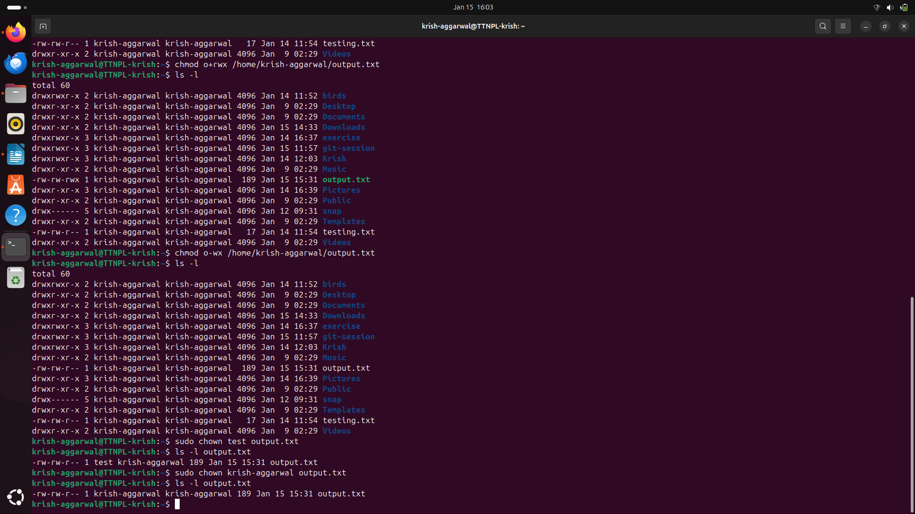

Q11. Create alias with your name so that it creates a file as "/tmp/aliastesting

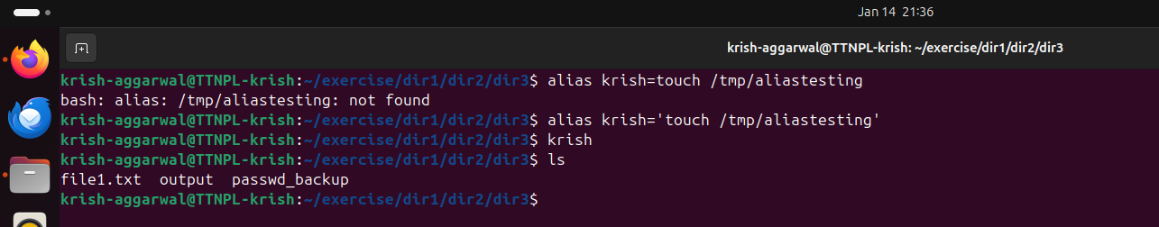

Q12. Edit ~/.bashrc file such that when you change to "test" user it should clear the screen and print "Welcome".

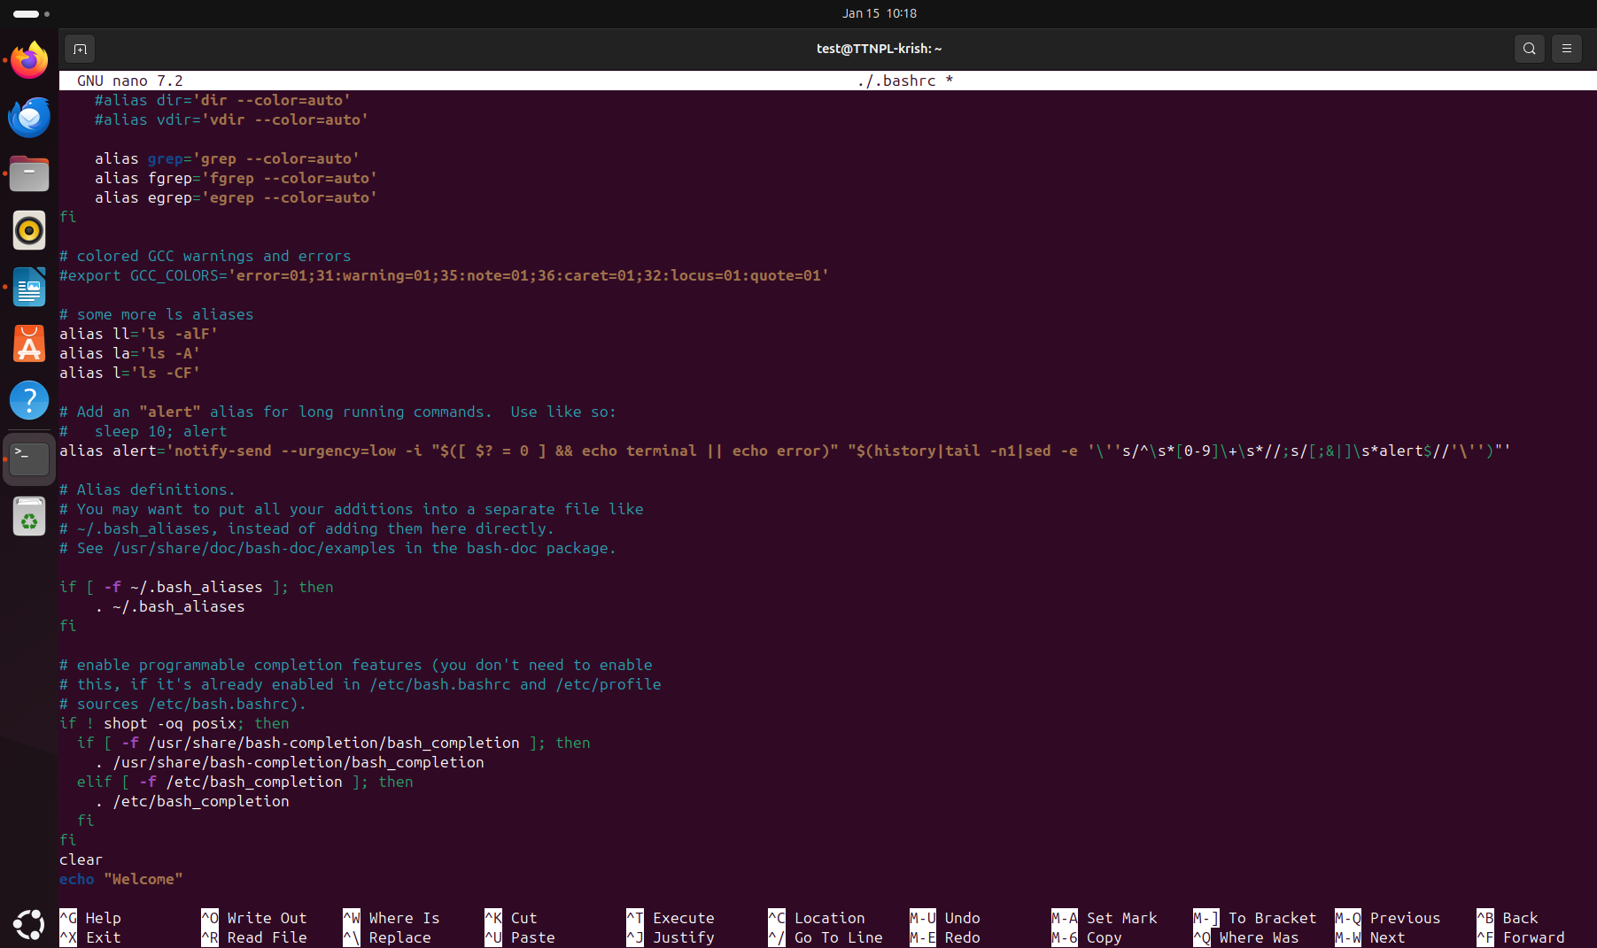

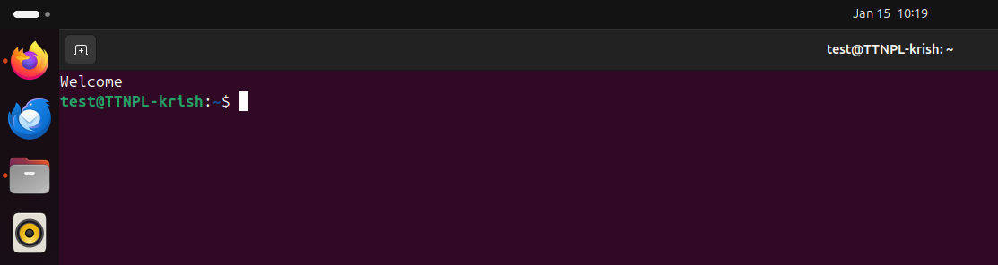

Q13. Install “zip” package.

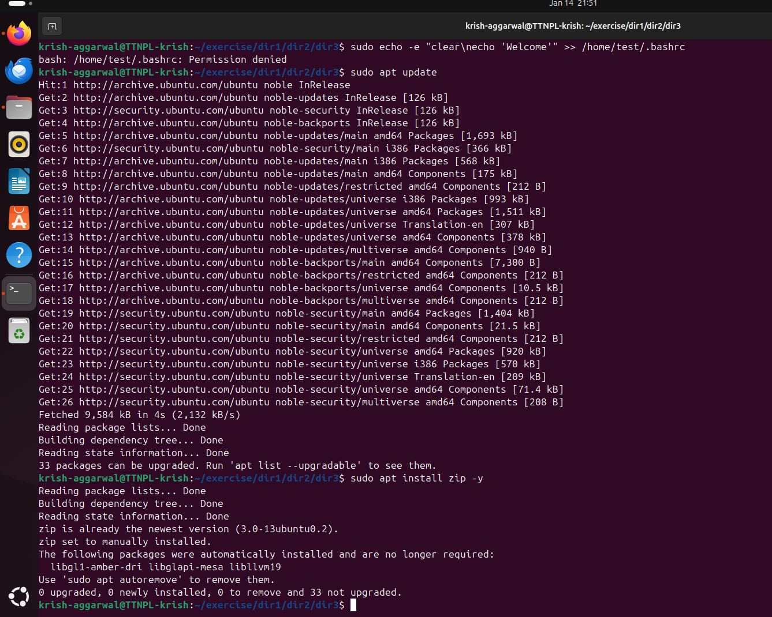

Q14. Compress "output" and "password_backup" files into a tar ball. List the files present inside the tar created.

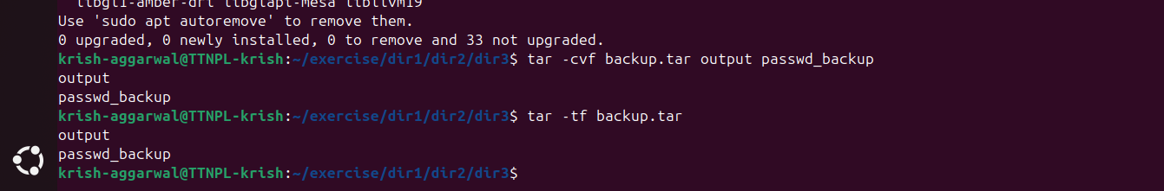

Q15. scp this file to test user home location.

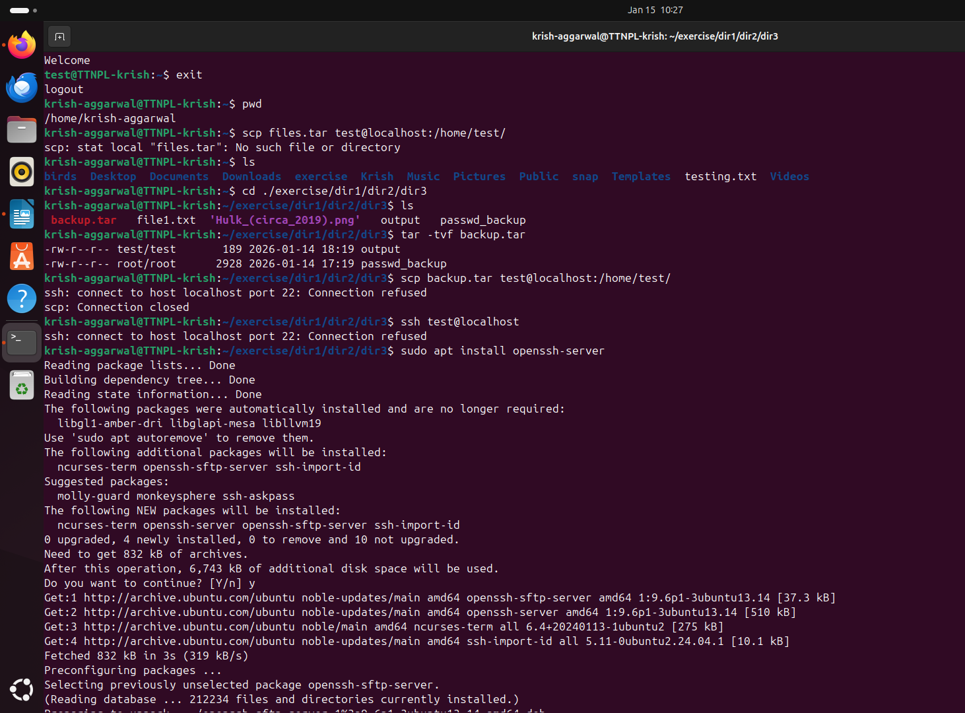

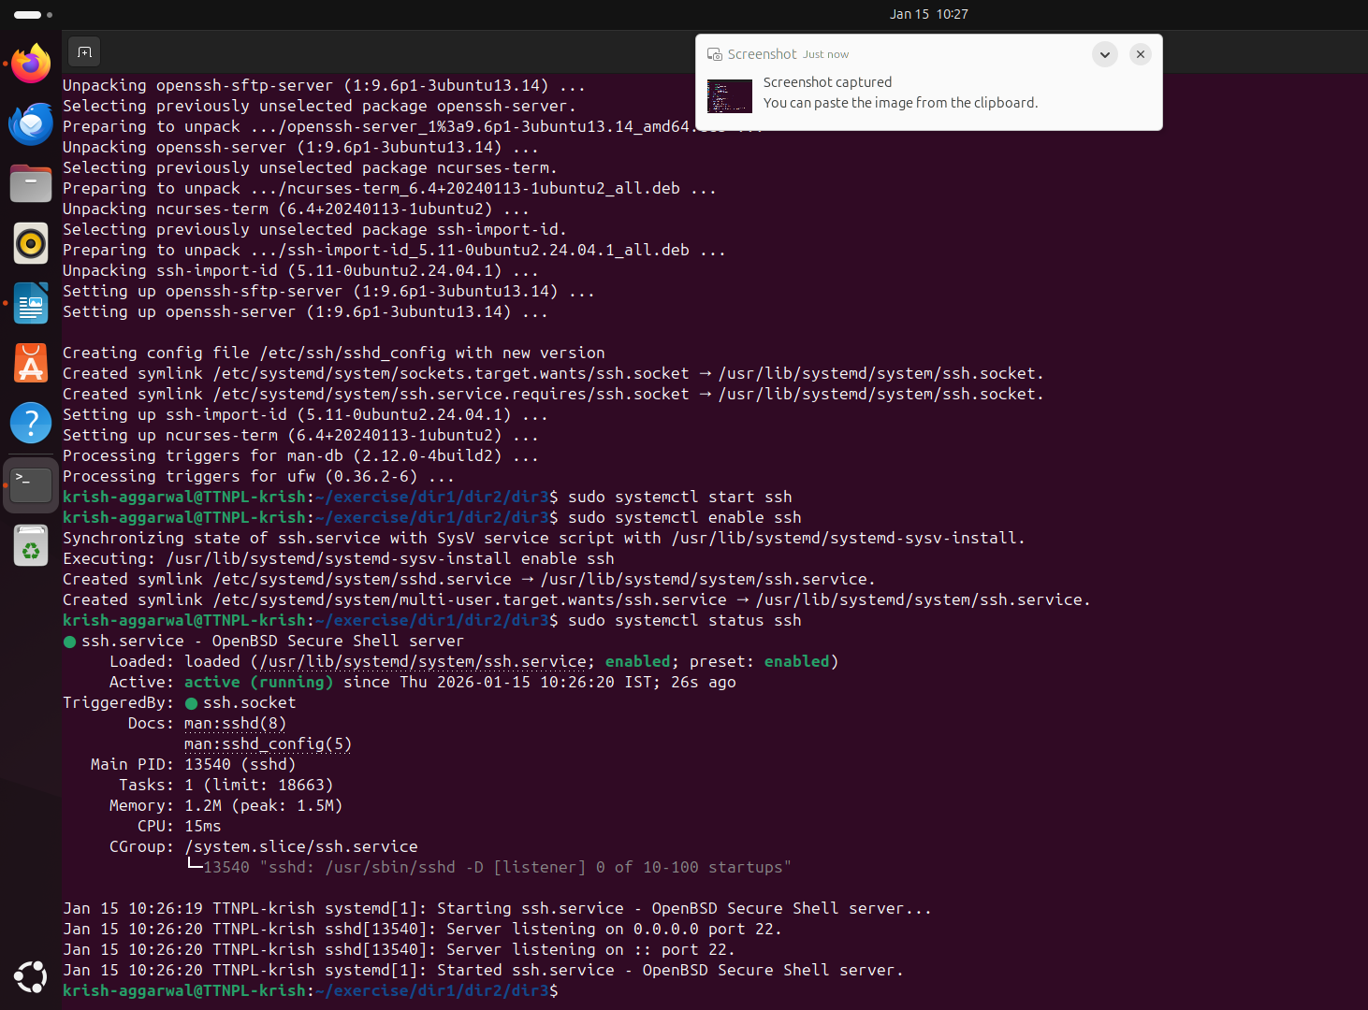

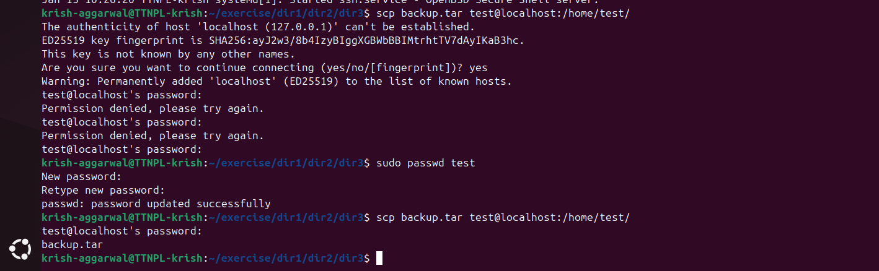

Q16. Unzip this tar bar by logging into the remote server

Ans: we can use this:

ssh test@localhost

tar -xvf ~/backup.tar -C ~/

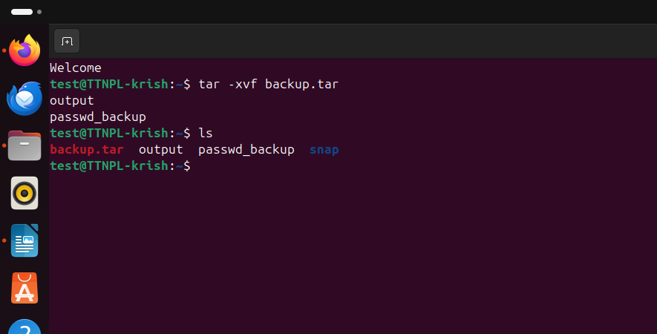

Q17. Download(via cli) any image from web and move(via cli) to test user home location.

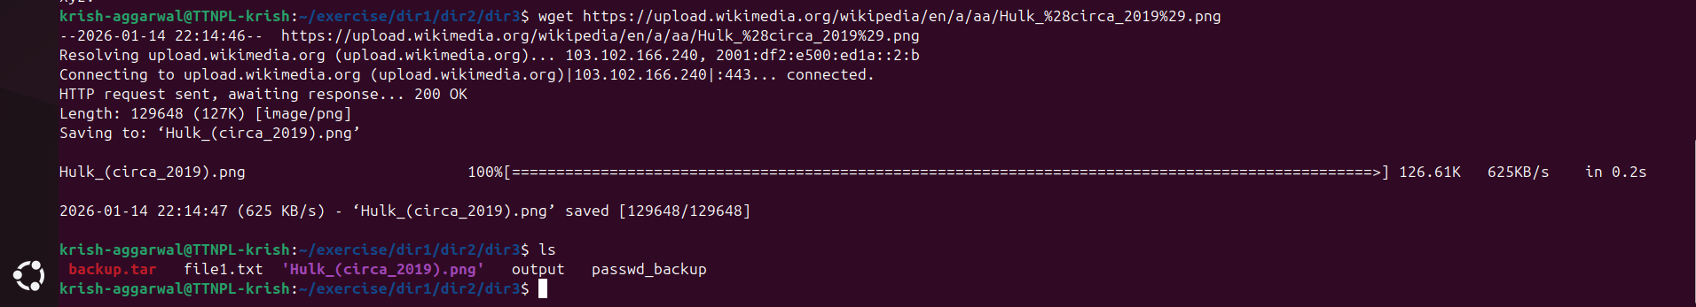

Q18. How to get help of commands usages.

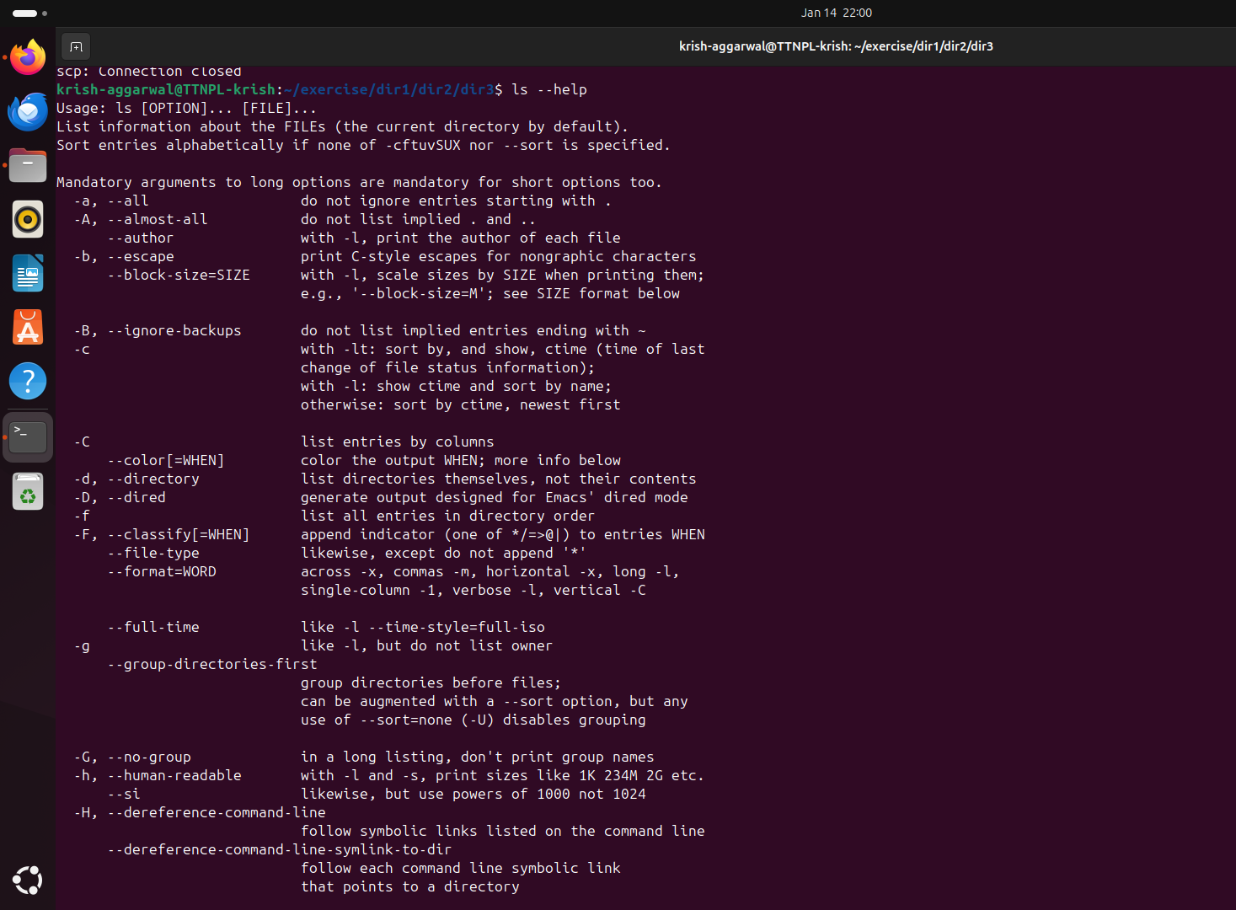

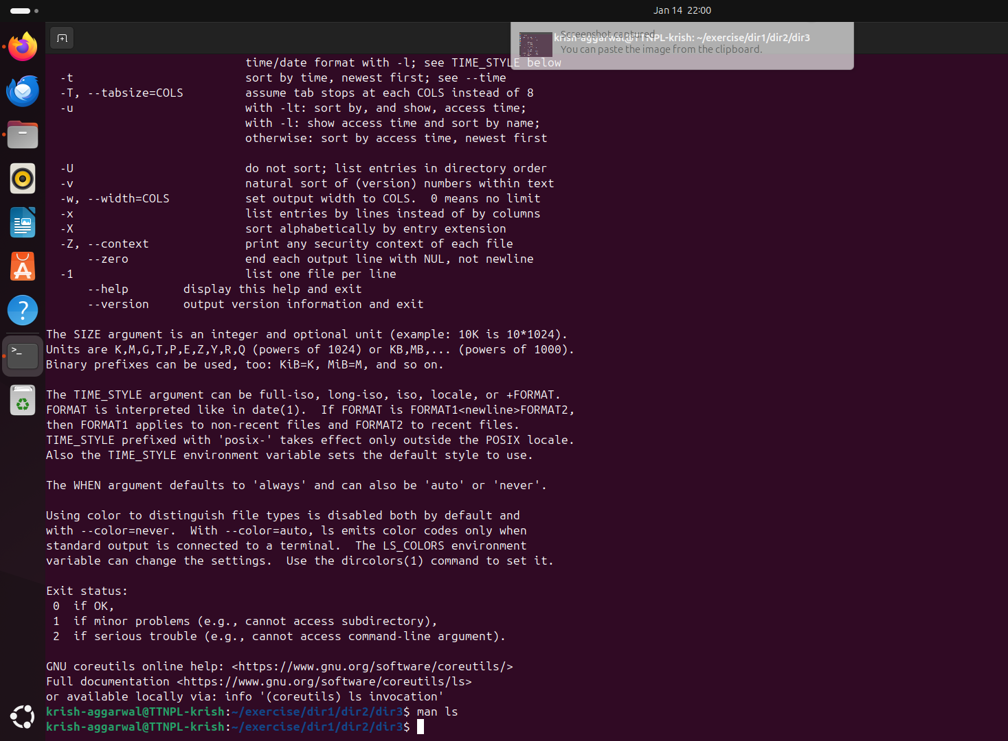

Q19. Create a symlink of /etc/services into /tmp/ports-info

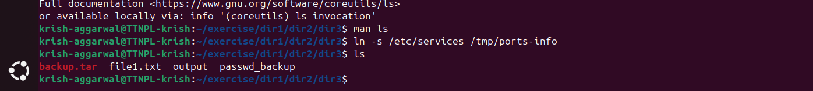



Q20. You are appointed as a Software Engineer in ABC media services. On your first day you need to troubleshoot a problem. There is a command “xyz” somewhere installed in that linux system. But as a new joinee you do not have any idea about where is that Installed. How can you check that?

**Ans**. Here are the most effective ways to find the location of the command **xyz** in a Linux system:

1. which command

2. whereis command

3. type command

